Unit 3: Test 3 Name: _________________________

Redox chemistry/galvanic cells Mark: ______/50

SECTION A – Multiple-choice questions

Instructions for Section A
Answer all questions.
Choose the response that is correct for the question.
A correct answer scores 1, an incorrect answer scores 0.
Marks are not deducted for incorrect answers.
If more than one answer is completed for any question, no mark will be given.

Question 1
The formula of a bromite ion is BrO₂⁻.

The oxidation number of bromine in the above ion is
A. -1
B. +3
C. +5
D. +7

Use the following information to answer questions 2 and 3
The equation for the reactions in a zinc-carbon cell are:

Zn(s) Zn²⁺(aq) + 2e

2NH₄⁺(aq) + 2MnO₂(aq) + 2e Mn₂O₃(s) + 2NH₃(aq) + H₂O(l) (carbon electrode)

Question 2
In this cell,

A. electrons will flow from the negative zinc electrode to the positive carbon electrode.
B. the total mass will drop as the cell discharges and uses up the zinc metal.
C. oxidation will occur at the carbon electrode, releasing electrons to flow through the wire.
D. electrons will flow to the zinc electrode and oxidise the zinc

Question 3
The oxidation change occurring at the cathode is

A. Zn moving from 0 to +2
B. Mn changing from +4 to +2
C. Mn changing from +4 to +3
D. N changing from -4 to -3

Question 4
The half equation 2H₂O(l) + 2e ⇌ H₂(g) + 2OH⁻(aq) is listed on your electrochemical series. A half-cell constructed for this half-equation will require

A. an inert electrode placed in an alkaline solution.
B. H₂ gas supplied to an inert electrode in a neutral solution.
C. H₂ gas supplied to a metal electrode in an alkaline solution.
D. H₂ gas supplied to an inert electrode in an alkaline solution.

Use the following information to answer questions 5 and 6
The following half-cells are connected:
Half-cell 1: A tin electrode in a Sn(NO₃)₂ solution.
Half-cell 2: A graphite electrode in a mixture of FeCl₃ and FeCl₂ solutions.

Question 5
In this cell

A. electrons will flow from the tin electrode to the graphite electrode.
B. the oxidising agent is Sn²⁺ ions.
C. Fe²⁺ ions are oxidised to Fe³⁺.
D. iron metal will form from Fe²⁺ ions.

Question 6
Select the correct statement about the electrode masses as this cell discharges.

A. Both electrodes will lose mass.
B. The mass of the graphite electrode is unchanged but the tin electrode gains mass.
C. The mass of the graphite electrode is unchanged but the tin electrode loses mass.
D. The mass of the tin electrode is unchanged but the graphite electrode gains mass.

Question 7
Which of the following lists species in order of increasing reducing strength?

A. Ni²⁺, I₂, Ag⁺, F₂
B. Cl⁻, Ag, I⁻,Ca
C. F₂, Ag⁺, Ni²⁺, I₂
D. Ca, I⁻, Ag, Cl⁻

Question 8
A balanced half-equation for the formation of hypochlorite ion (ClO⁻) from the chlorate ion (ClO₃⁻) ion is

A. ClO₃⁻ ClO⁻ + 2O²⁻
B. ClO₃⁻ + 2H⁺(aq) ClO⁻ + H₂O(l) + 2e
C. ClO₃⁻ + 4H⁺(aq) + 4e ClO⁻ + 2H₂O(l)
D. ClO₃⁻ + H₂O(l) + 4e ClO⁻ + 4H⁺(aq)

Use the following information to answer questions 9 and 10
The hydrogen fuel cells shown in most text books are operating in acidic conditions. The fuel cells, however, used in early space missions ran in alkaline conditions.
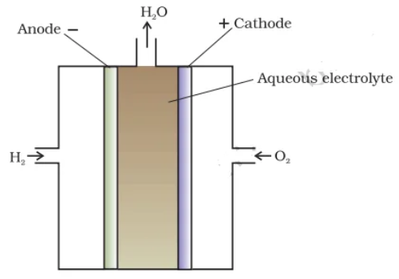

OH⁻

Question 9
In this cell, the overall equation is

A. 2H₂O(l) 2H₂(g) + O₂(g)
B. 2H₂(g) + 2OH⁻(aq) 2H₂O(l)
C. 2OH⁻(aq) + O₂(g) 2H₂O(l)
D. 2H₂(g) + O₂(g) 2H₂O(l)

Question 10
Select the correct statement about this cell.

A. The nature of the electrodes will ensure this cell is relatively expensive.
B. This cell can be recharged easily after it has completely discharged.
C. H⁺ ions will flow toward the negative electrode during discharge.
D. The electrodes should be made from an inert material such as graphite.

SECTION B- Short-answer questions

Instructions for Section B
Questions must be answered in the spaces provided in this book.
To obtain full marks for your responses you should
- Give simplified answers with an appropriate number of significant figures to all numerical questions; unsimplified answers will not be given full marks.
- Show all workings in your answers to numerical questions. No credit will be given for an incorrect answer unless it is accompanied by details of the working.
Make sure chemical equations are balanced and that the formulas for individual substances include an indication of state; for example, H₂(g); NaCl(s)

Question 1 (13 marks)
a. Vanadium can exist in more oxidation states than most other elements.
Determine the oxidation number of vanadium in each of the following: 4 marks

i. V₂O₅ ______ ii. VO₃⁻ ________

iii. V₂O₄ ______________ iv. VO₂⁺ _________

b. Complete and balance the following half equations involving vanadium.

i. VO₂⁺ VO²⁺ 1 mark

ii. VO²⁺ V³⁺ 1 mark

iii. Label each of the above reactions as oxidation or reduction 2 marks

c. For the reaction below:
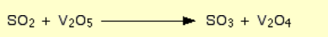

i. State the oxidation state change of the sulfur _____________________________________ 1 mark

ii. Identify the reducing agent __________________________________________________ 1 mark

d. Given the following half-equations:
V³⁺(aq) + e ⇌ V²⁺(aq) Eº = -0.26 V

NO₃⁻(aq) + 4H⁺(aq) + 3e ⇌ NO(g) + H ₂O(l) Eº = 0.96 V

i. Write an overall equation for the spontaneous reaction that can occur when these half-cells are connected.
1 mark
____________________________________________________________________________________

____________________________________________________________________________________

ii. Identify the oxidising agent in this reaction _________________________________ 1 mark

iii. Determine the theoretical voltage ________________________________________ 1 mark

Question 2 (8 marks)

Complete the template below to show the half-reactions occurring in this cell. Show
- the polarity of the electrodes
- possible solutions in each cell
- the material the electrode is made from
- direction of electron flow
- ion movement on salt bridge

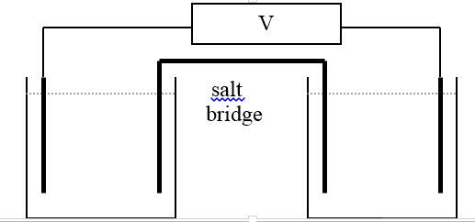

Oxidation half equation Reduction half-equation

__________________________ ________________________________

Overall equation ______________________________________________________

Theoretical cell voltage ____________________________
8 marks

Question 3 (6 marks)
The diagram below shows a sketch of the Li/S₈ cell. The product formed in this cell is Li₂S. It does not operate in an aqueous environment. The voltage produced by the cell is 2.15 V.
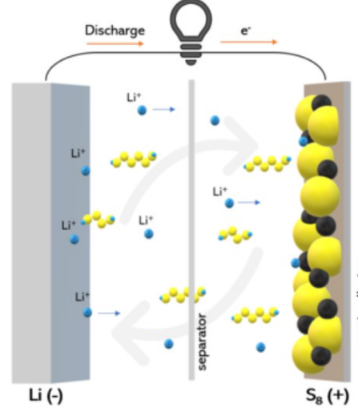

a. Use the headings below to write half-equations and an overall equation for the reaction between Li and S:
(states not required)

Anode: ______________________________________________________________________ 1 mark

Cathode: ______________________________________________________________________ 1 mark

Overall equation: ________________________________________________________________ 1 mark

b. Label on the diagram
i. the direction of electron flow 1 mark

ii. the polarity of the electrodes. 1 mark

c. Determine the E value of the sulfur half-equation. 1 mark

___________________________________________________________________________

Question 4 (13 marks)
A fuel cell using methane and oxygen is drawn below. The cell operates in acidic conditions.
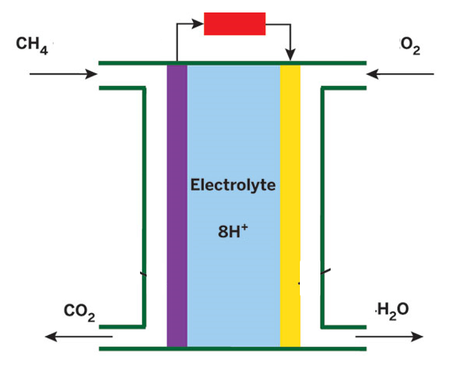

a. Use the template below to show the half equations and overall equation for this cell. 3 marks

Anode reaction : _____________________________________________________

Cathode reaction: _____________________________________________________

Overall equation: ____________________________________________________________

b. Label the diagram above with

i. an arrow indicating the direction of flow of ions in the cell. 1 mark

ii. the polarity of the cell. 1 mark

c. i. The electrodes in this cell are the complex part of this cell. Explain their function in this fuel cell. 2 marks

___________________________________________________________________________________

___________________________________________________________________________________

ii. State one difference between a fuel cell and a primary cell. 1 mark

_____________________________________________________________________________________

d. Discuss the sustainability of the widespread introduction of these cells. In your response, refer to a green
chemistry principle. 3 marks

___________________________________________________________________________________

___________________________________________________________________________________

___________________________________________________________________________________

___________________________________________________________________________________

e. Determine the maximum amount of charge that could be formed from the reaction of 4.0 g of
methane. 2 marks

___________________________________________________________________________

___________________________________________________________________________

END OF KEY TOPIC TEST

